Урок английского языка в Музее Победы для инженерных классов
War Effort: Engineering

Кейс 1 (базовый уровень)
Case I
Visit the English version of the Museum’s website.
https://victorymuseum.ru/for-visitors/museum-for-china/en/
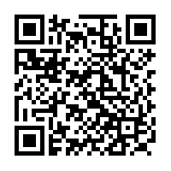
Use the information provided to answer the following letter you received from your English-speaking friend Debby.
…I’m really looking forward to my trip to Moscow! I’m especially interested in visiting the Victory Museum. As you may remember, I’m a fan of military history. How can I learn about the battles of the Great Patriotic War in the museum? Is there any information on the weaponry used during WWII? I’m going to travel with my parents and my 7-year-old brother. Will we be able to go on a guided tour?
By the way, I’ve decided to become an army engineer…
Write a letter to Debby. Use the information leaflet below to answer her questions. Ask three questions about her future profession.
Write 100 – 140 words. Remember the rules of letter writing.

Кейс 2 (углубленный уровень)
Case II
Read an article on the Soviet engineers’ contribution to winning the war and choose a passage for translation into English.
https://www.computer-museum.ru/connect/vov_nauka.htm
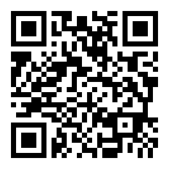
Analyze the text:
- which grammar structures will you need to use?
- Which words and phrases do you need to look up?
- Are there any style and register peculiarities?
Make a glossary of necessary vocabulary.
Write a draft of the translation.
Do error correction.
Exchange translations with your peers, assess each other’s works and provide feedback. Consult with your English teacher. Edit the translation based on your peers’ and teacher’s recommendations.

